ITEMS REQUIRING ADDITIONAL FEES

Fees for these items are necessary to cover the disposal. Fees can be paid at the Town Office or the Transfer Station. Cash or check only.
Please make checks out to “Town of Mechanic Falls”.
17"-22" | $5 |  | less than 25'x25' | $10

MECHANIC FALLS TRANSFER STATION GUIDE
Hours of operation Sunday 8 am to 1 pm
Wednesday Noon to 4 pm
Saturday 8 am to 4 pm
Phone: 345-3556
Located on Austin Road

Tires |  | Carpet

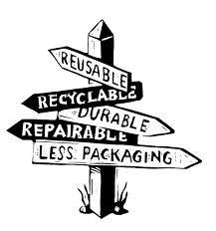

King $15 Pianos/organs $15
20# | $1 |  | stuffed chair | $5

100# | $20 |  | Couch | $10

up to 16" | $2 | less than 10'x10' | $5
22"-25" | $30 | greater than 25'x25' | $15
Refrigerators, ACs,  Dehumidifiers | $10
Propane Tanks |  | Furniture
30# | $5 | Recliner | $10
 |  | Sofa bed/recliners | $15
Mattresses
twin | $5 | Pool liner | $10
full/queen | $10

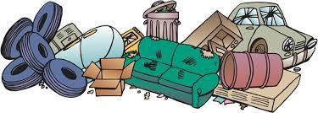

This list is only a guideline and not all inclusive. Bulky items not on this list will be subject to fees determined by your Transfer Station Staff. Ask an attendant how to avoid fees.
In order to use our transfer station, there are some very simple rules which must be followed!

- You must be a resident of Mechanic Falls and have a valid Transfer Station Sticker.
- You must recycle. Failure to do so will result in your loss of the ability to use our Transfer Station.
- All loads will be inspected by an attendant even if instructions are not needed as to where waste is to be deposited

See attendant for items worth swapping or to purchase metal items No black or green bags!!
The Mechanic Falls landfill can no longer accept sheetrock or singles for disposal. Attendants have information for proper disposal outlets for those items. Always check with attendant before using the landfill.

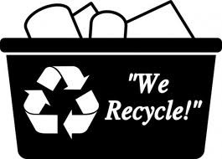Recycling is mandatory!!
If you are unsure about any particular items, check with the attendants. They are there to help you!
These items should be sorted prior to arriving!!

Corrugated Cardboard
- Mixed Paper
  - Cereal boxes and boxes such as this, books, junk mail, paper milk and juice boxes, egg cartons
  - Please, not food contaminated paper or used paper towels/tissues
- Newspaper and Magazines
- #1 & #2 Plastics
  - Laundry detergent bottles, milk jugs, condiment bottles
  - No motor oil containers please
  - Please remove caps from containers
  - Containers must be empty and rinsed for recycling
- Glass
  - Only empty and rinsed jars with lids removed please
- Tin Cans
  - Empty and rinsed
- Used Clothing (Salvation Army Bin)
  - Don’t worry about some tears or stains
- Electronics
  - TVs
  - Computers
  - Video Game Consoles
  - Stereo Equipment
  - Digital Picture Frames

- Lights/Batteries (See attendant for these items)
  - All fluorescent bulbs & CFLs
  - rechargeable batteries
  - Ballasts
  - Cell Phones

- Scrap Metal
  - No Paint Cans
  - Appliances, bicycles, metal pipes, and other metal items

- Brush
  - No stumps

- Compost
  - Please dump leaves out of plastic bags

- Inert Material
  - Concrete, bricks, ceramic

over

